# Web 3 Practical – JavaScript DOM

Solve each of the following exercises using JavaScript, HTML and CSS, as required.

1. Build a JavaScript file that prompts the user to enter a number. The script then calls a function that updates the HTML div element with id=divDisplay in the HTML file with a count backwards from the user input value all the way down to 1. So for instance, if the user inputs 5 in the prompt, your script should generate the following output in the browser by interfacing with the DOM.

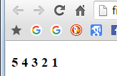

Hint: The innerHTML property of a DOM element could come in handy here

1. Another useful DOM element property is ‘style’. An element’s style is a collection of all its CSS properties. You can apply CSS rules dynamically to the element by modifying the style property. In this exercise, you are given a web page that contains a list and a button. I have specified an event handler for the button called changeTheList. Hence, you need to write a JavaScript function named changeTheList which changes the style of the list like the following images shows (clicking the button puts a border around the list, makes the border width 100px and sets its background color to orange).

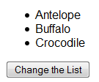 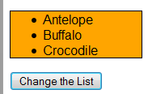

Before After

1. Replicate the functionality of exercise 2, but this time use assigning a class name to the ul element with id “ulAnimals”. Take advantage of the provided CSS file.
2. D:\Dropbox\Work\Teaching\IN712 - Web Programming 3\difficultyIcon.png The HTML file provided contains a button and a text box. The user types a string into the text box, and then clicks the button. When the button is clicked, the function countTxtInput() is called. countTxtInput should injected in the div element with ID “divDisplay” the number of vowels in the string input by the user. Encapsulate the counting of the vowels into its own function independent from countTxtInput. Remember that you must count both uppercase and lowercase vowels. The output should look similar to:

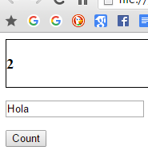

1. D:\Dropbox\Work\Teaching\IN712 - Web Programming 3\difficultyIcon.pngWrite a JavaScript function **displayObjectInTable(o)**. This function accepts a single object as its input parameter and inserts the contents of that object (i.e. its key:value pairs) in the DOM in the form of a table at the bottom of the web page. You can use a simple object containing 2 teams and their corresponding scores on a game. Make sure to use methods to modify the DOM on the fly such as .createElement, .createTextNode, .appendChild. Ensure that the table is styled neatly, with collapsed borders and appropriate padding and alignment. Some sample code that could be useful to achieve the task in this exercise is given below:

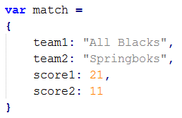

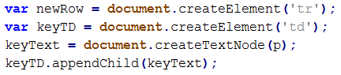

After repeatedly clicking the button 5 times, your browser should look like:

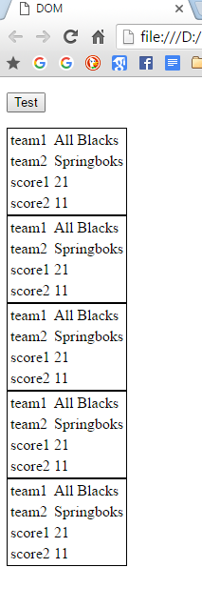

1. Use the geolocation object to retrieve the latitude and longitude of the device where the browser is running. Display an error message if geolocation is not available.
2. Using the file p7.html, open the Chrome Debugger and set a breakpoint at line 18 of the file (var product = multiply(timesTable,counter);). Use the debugger to make sure you understand the functionality of the buttons: “step over next function call”, “step into next function call” and “step out of current function”.